Phase 2
Web Application testing lab

Objective
The goal is to assess the security posture of a website by identifying vulnerabilities aligned with OWASP top 10. This includes manual testing and automated testing to discover issues such as SQL Injection and Cross-site Scripting (XXS) and demonstrate impact of such vulnerabilities.

Tools used
- Kali Linux
- Metasploitable VM
- Burp suite
- SQLmap

Methodology
- Performing Reconnaissance on DVWA Website
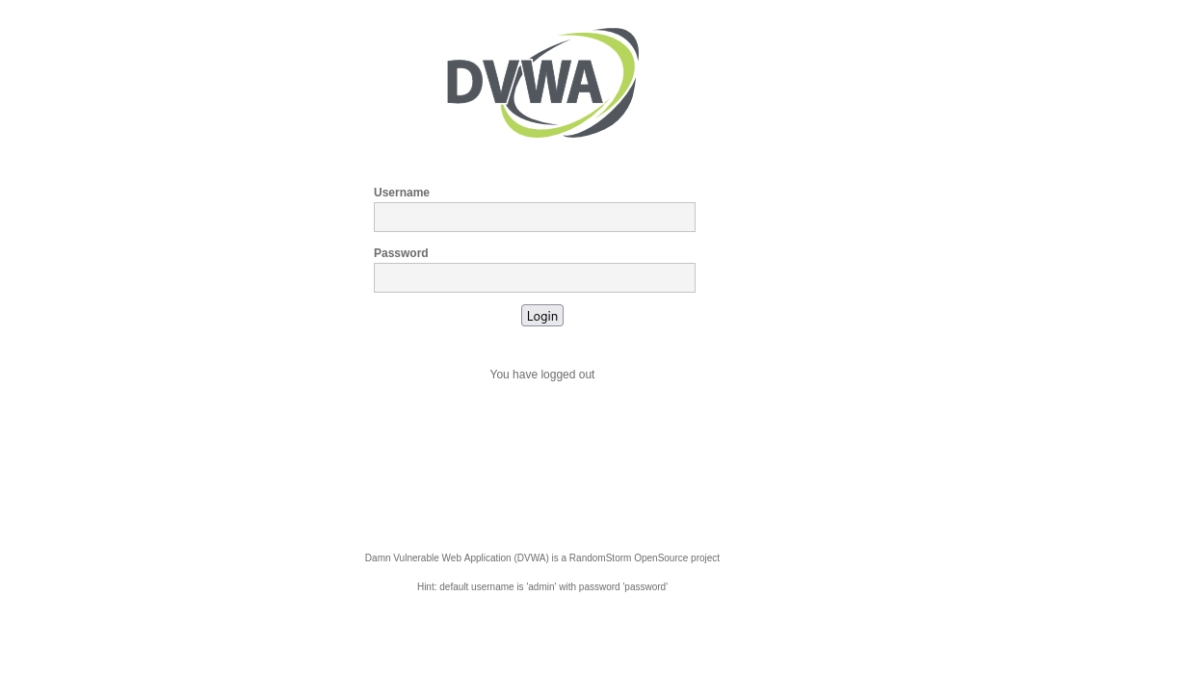
Here is the DVWA login page. The Default Credentials for login is Username “admin” Password “password”.
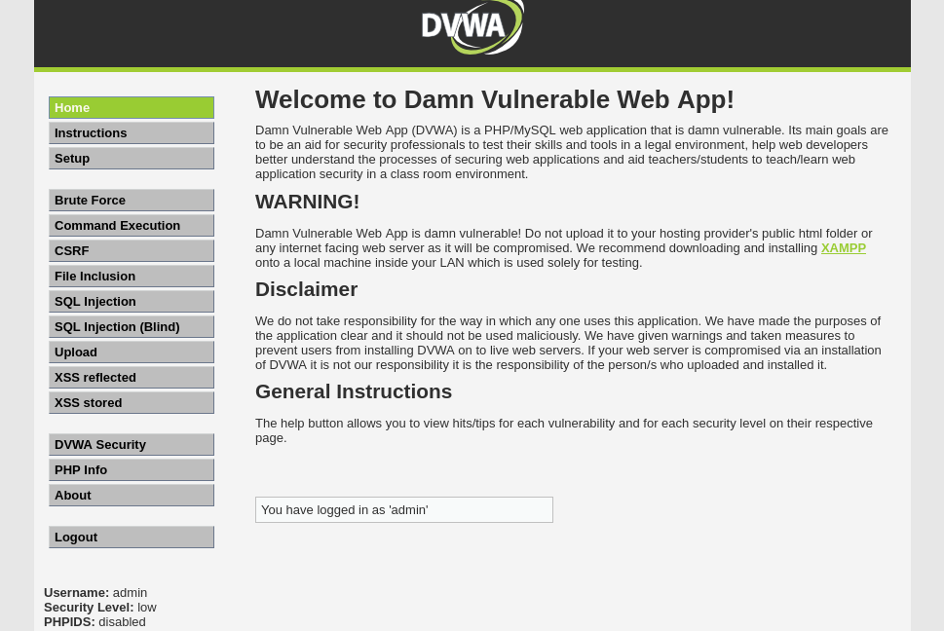
This is the Home/Configuration page of the DVWA website where we can perform Penetration testing. We will proceed with the Cross-site Scripting i.e. XSS Reflected, SQL Injection, and further OWASP top 10 vulnerabilities.
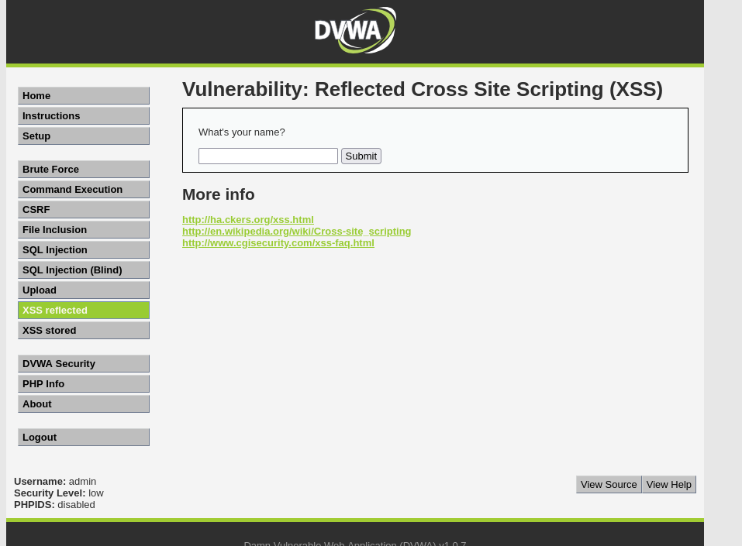
- Burp suite and Testing for XSS Reflected.
Burp suite can be launched using the command burp suite in the terminal.
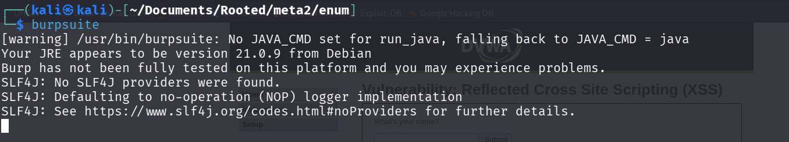
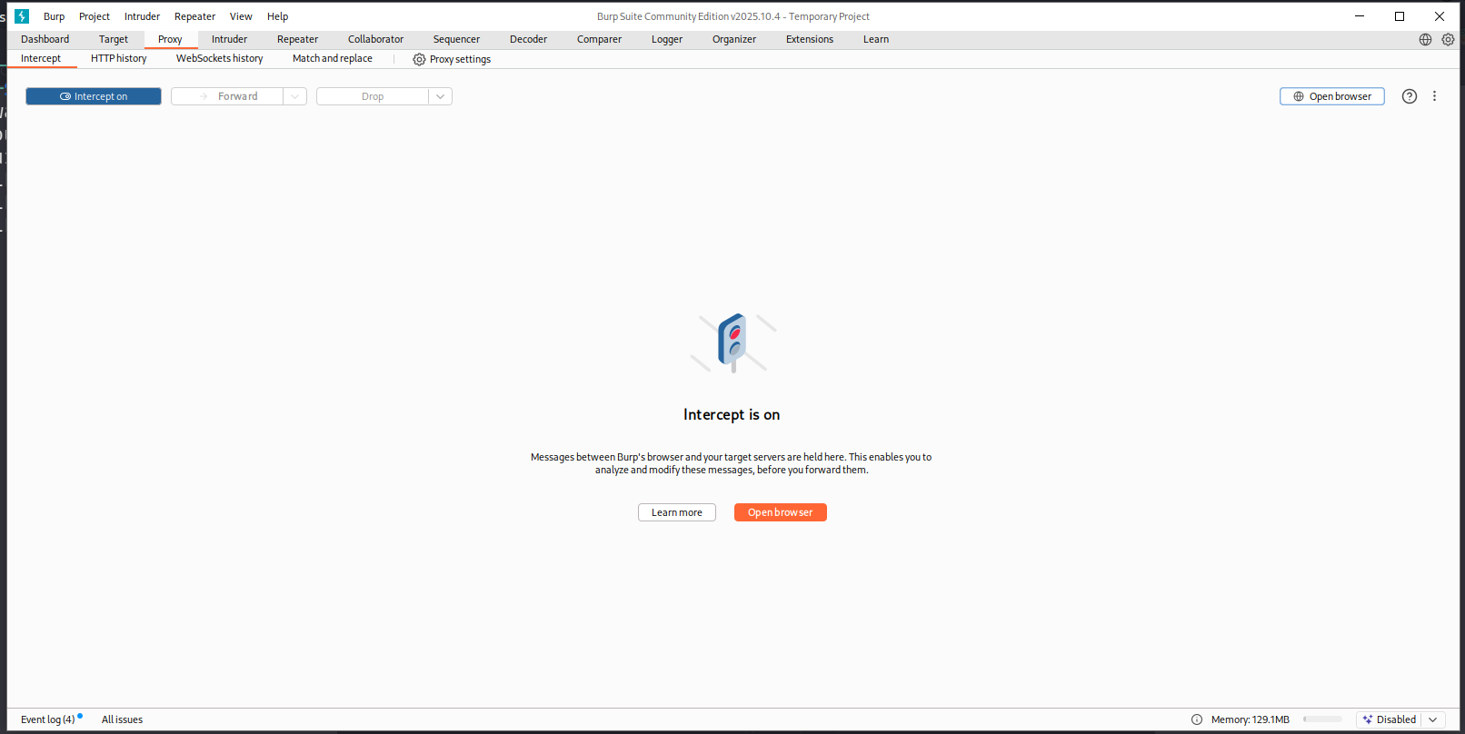
We Have Configured Burp suite primitively and we turn on the intercept and setup foxy proxy to intercept traffic to DVWA website.
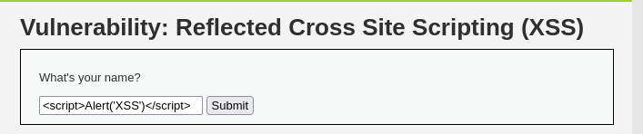
Performing basic cross site scripting test.
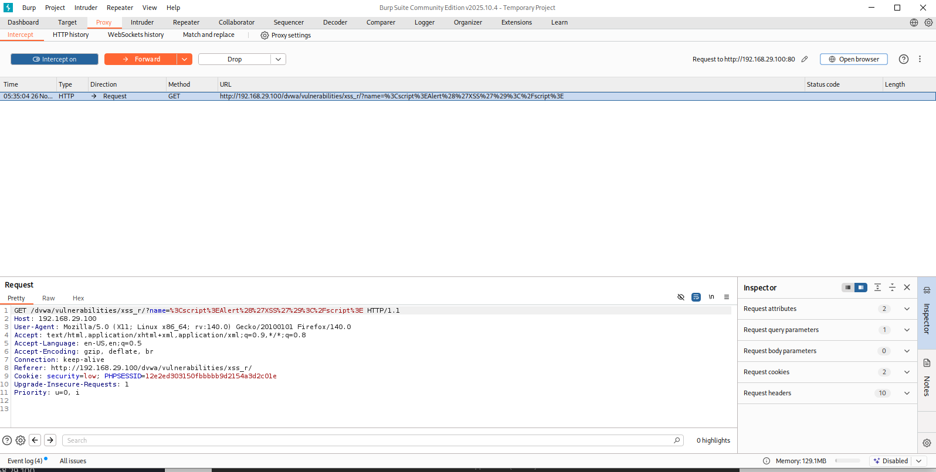

The request is captured as intended in the burp suite. We allow the request to pass through to see if there is any cross-site scripting vulnerability.
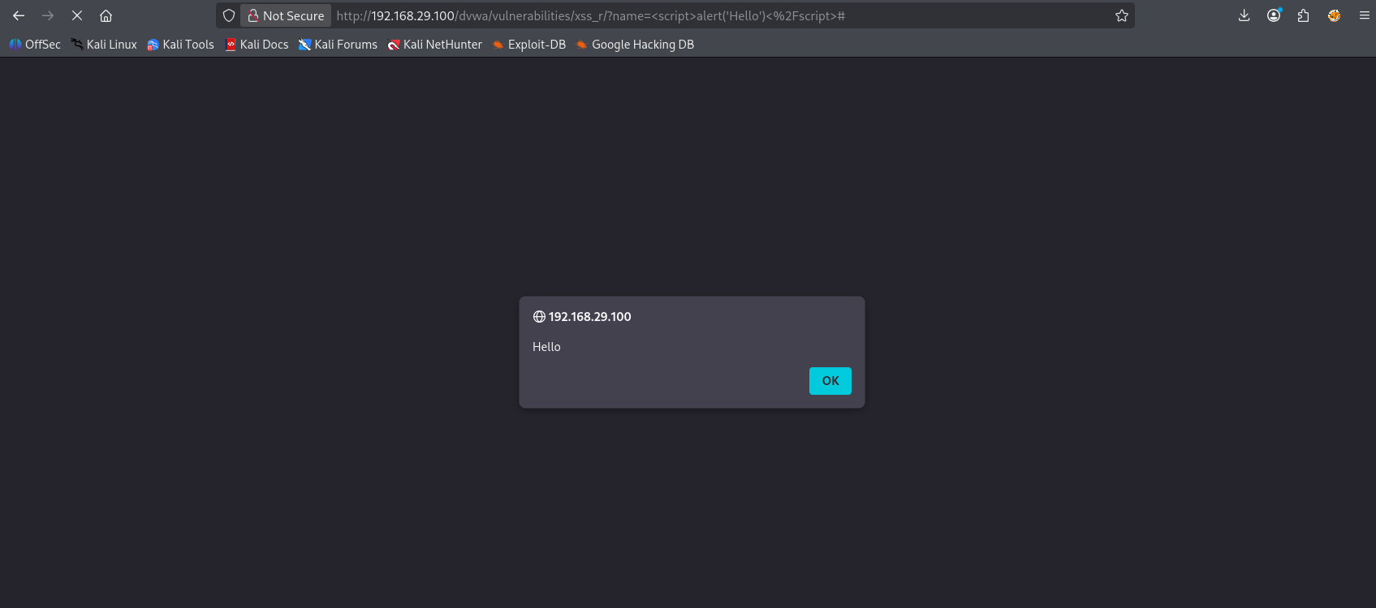
This above snapshot confirms the Client side Reflected XSS vulnerability.

- Performing session Hijacking by stealing cookies
We Setup our netcat to listen to anything in port 4444.
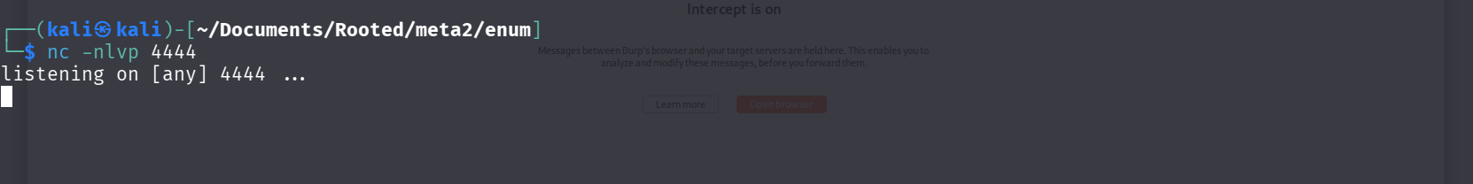
Then we use this Script to steal session cookies.
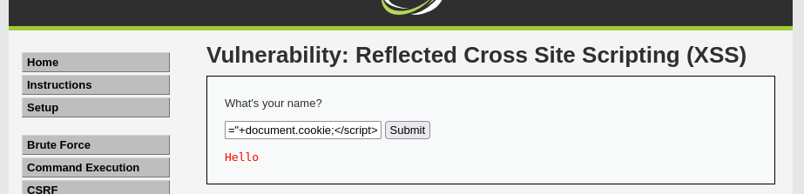

Bingo, we got the cookies in our attacker machine as intended.
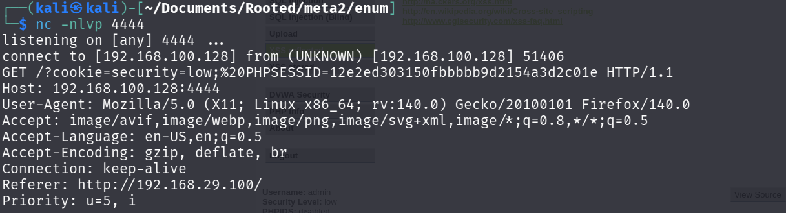
The Phpsession Id Cookie was captured.
PHPSESSID=12e2ed303150fbbbbb9d2154a3d2c01e
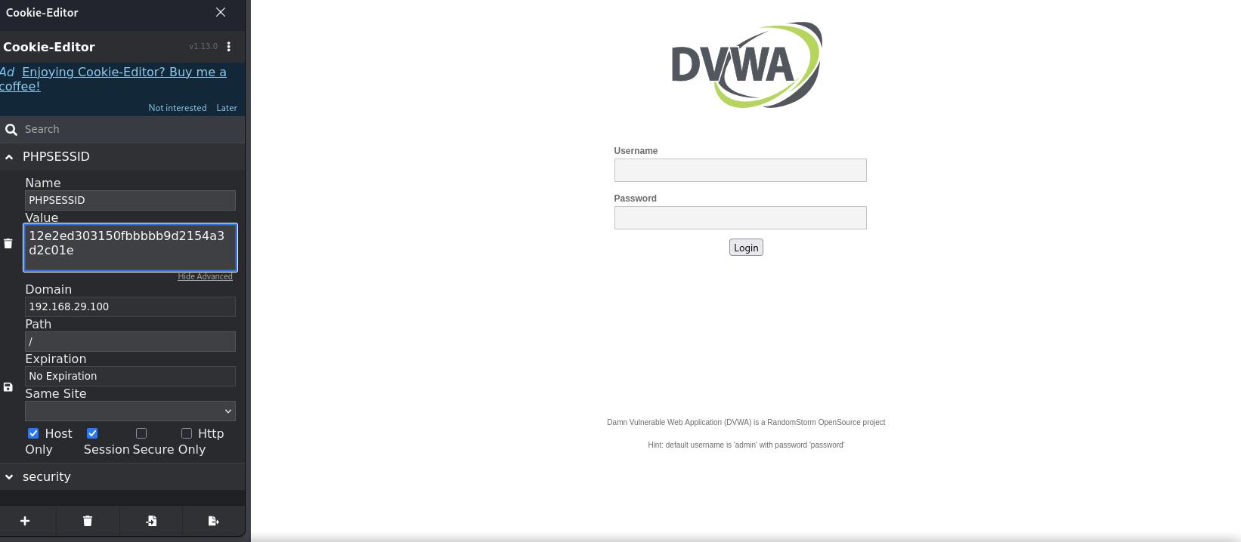
Using the Session ID, we captured we can use it hijack the session without any credentials. By above snap shot we can determine that by using the cookie editor extension we were able to successfully change the cookies.
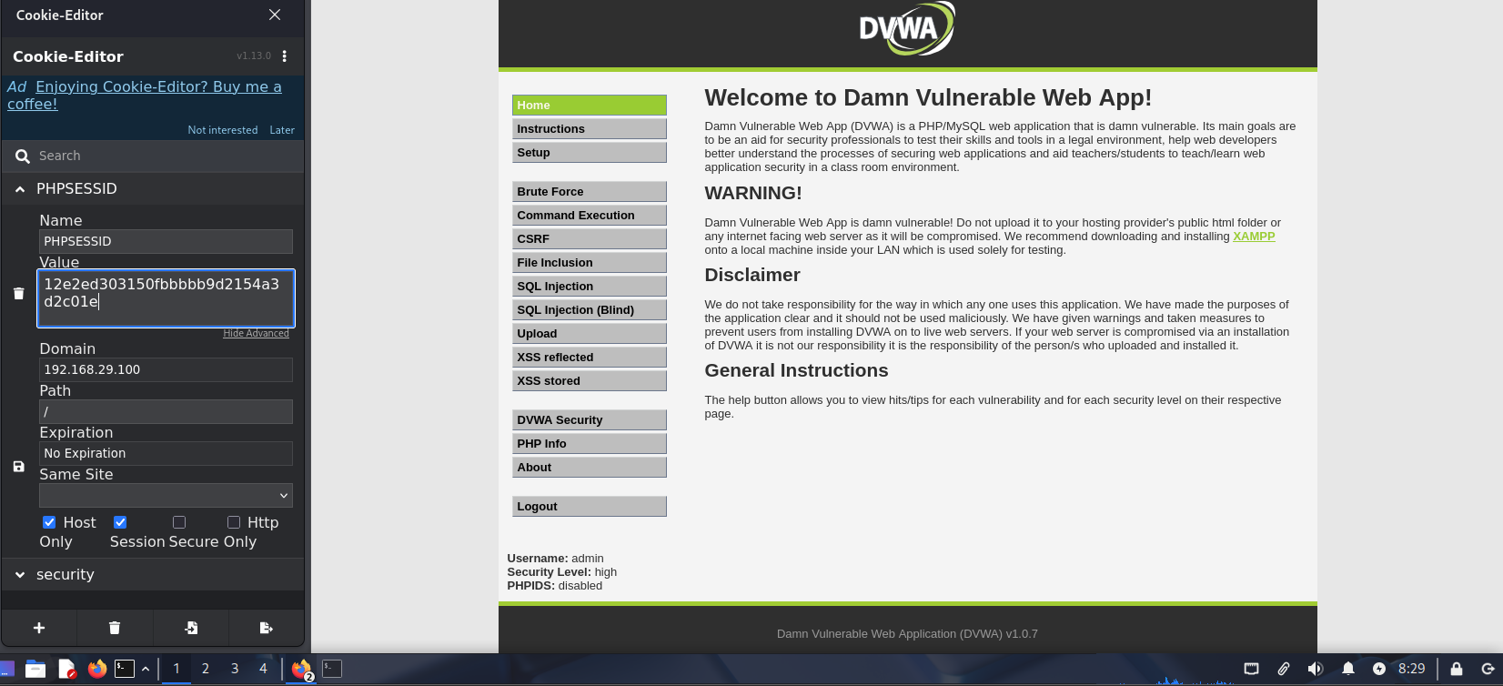
By the above snapshot we come to conclusion that we were successfully able to Hijack the session. This concludes that a simple XSS vulnerability resulted in Account takeover. For demonstration purposes we consider this account as admin’s account and whatever we do from this point onwards is considered done with admin privileges.

- Exploiting File upload Vulnerability to get Remote code execution (RCE).
For this vulnerability we use php-reverse-shell.php as payload. We can find this payload default in Kali Linux.
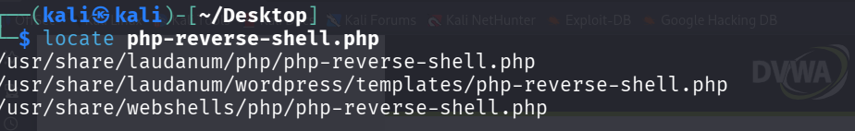
We make a copy of this for our use and paste it in desktop. We edit this file making the changes in the section IP and Port.
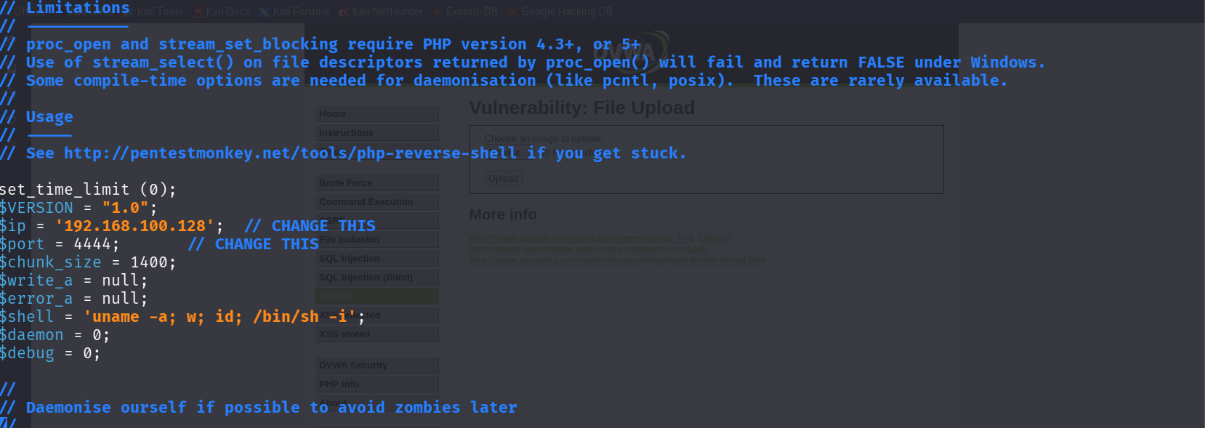
As we change the IP address to our attacker machine and port to 4444. Now we will open Net-cat listener on port 4444
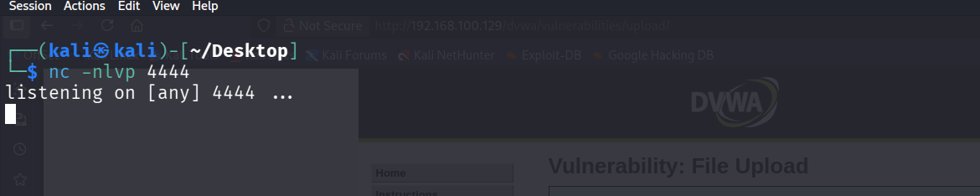
Now we upload this file to the DVWA file upload area.
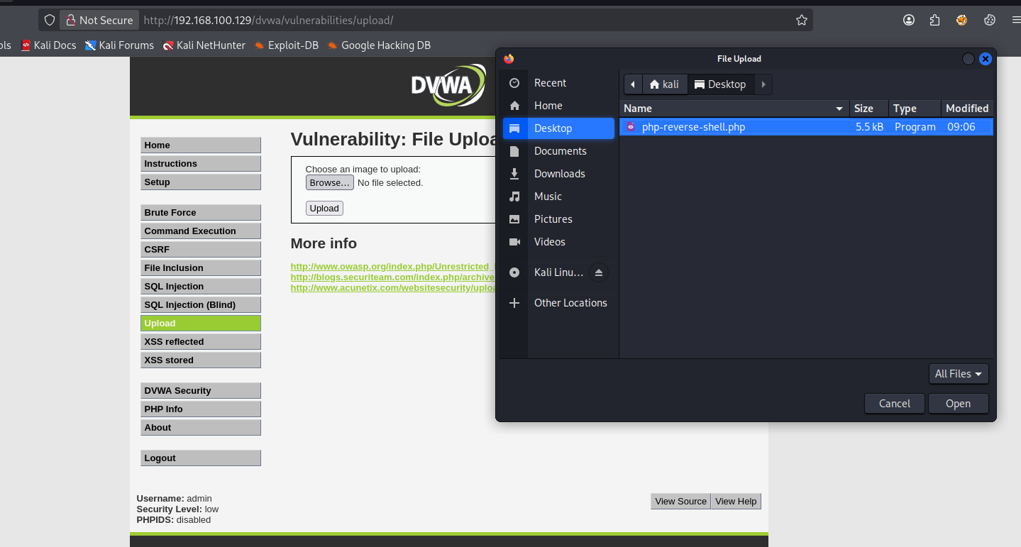
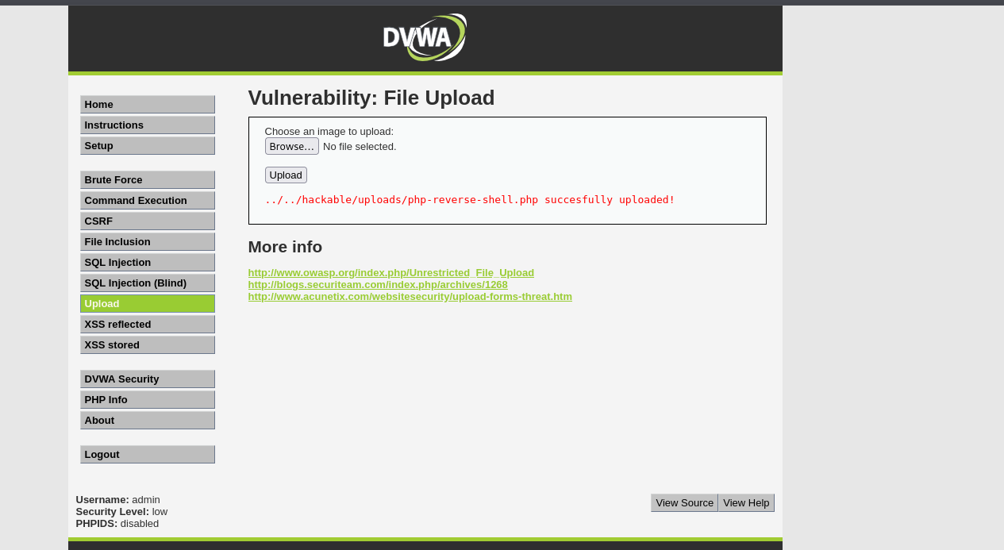
Now we will open this file in the browser.
http://192.168.100.129/dvwa/hackable/uploads/php-reverse-shell.php

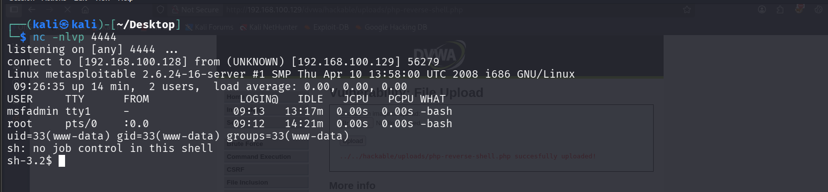
After Checking our Net-cat listener we can confirm that we were successfully able to execute remote code execution.

- Privilege Escalation to Root
Now we transfer linpeas.sh file which is a famous script used in Linux privilege escalation using python http server module. We run it in the target machine.
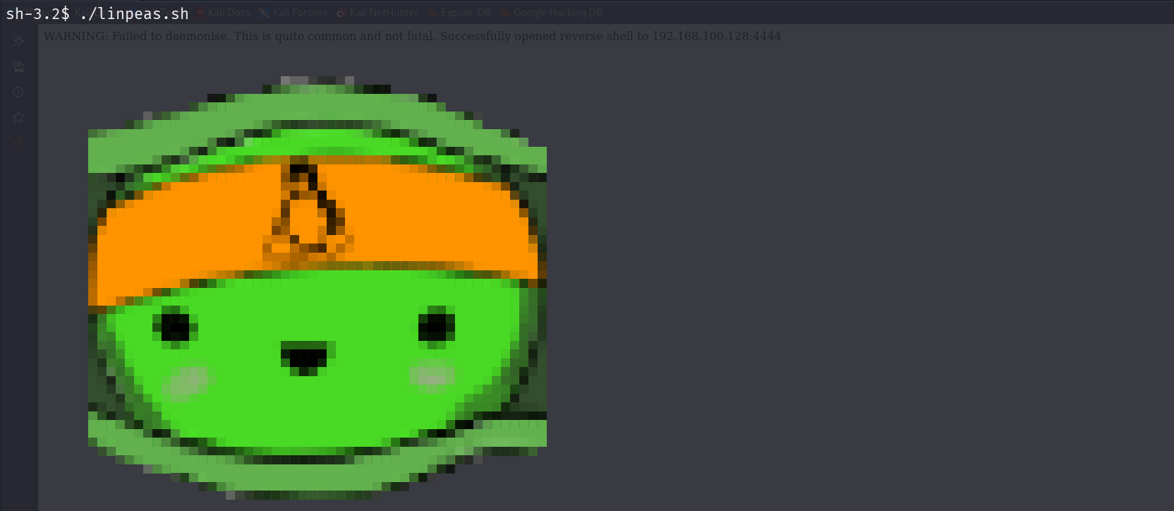
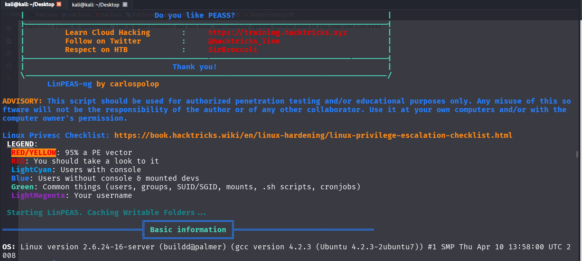
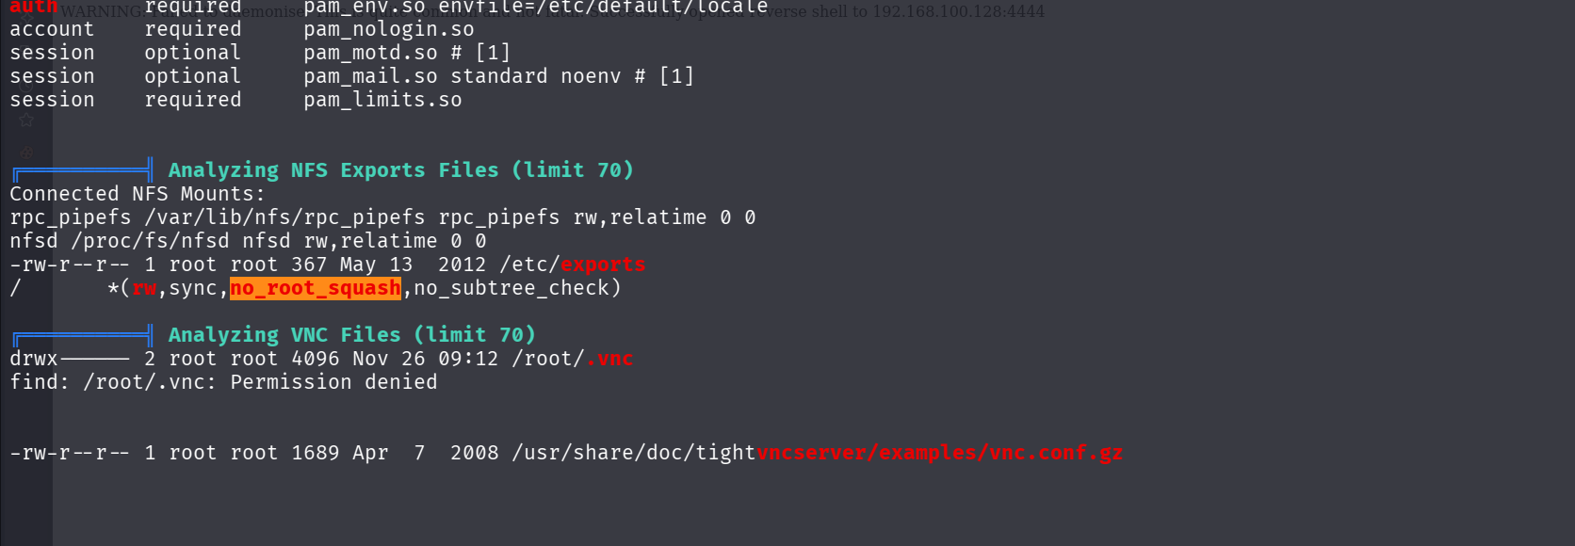
We find an interesting Privilege Escalation Vector.
/ *(rw,sync,no_root_squash,no_subtree_check)
The above line means entire root filesystem is exported over NFS with no_root_squash. Here no_root_squash means any files we create via NFS will be treated as root on the target system.
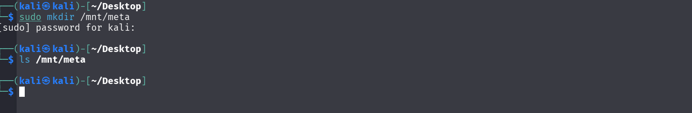
By using the below command, we are able to mount a folder on kali i.e. attacker machine to the target machine Metasploitable.
sudo mount -o rw 192.168.100.129:/ /mnt/meta
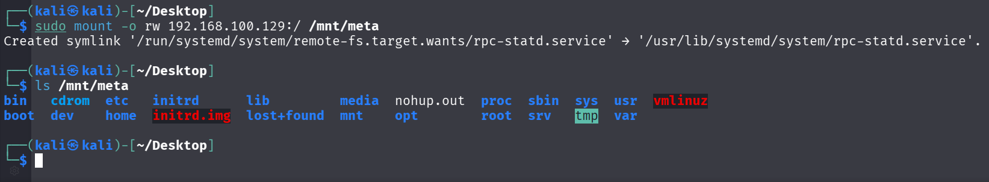
After mounting our folder to the target machine, we are able to access all files and folders present in Metasploitable. So, we add a user kali in the /etc/passwd file
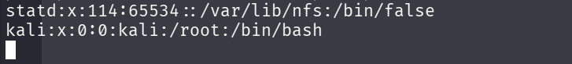
We also need to add corresponding password hash in the /etc/shadow file to make creation complete with root privileges.
After creating the user, we are now simply able to switch user and get root access.
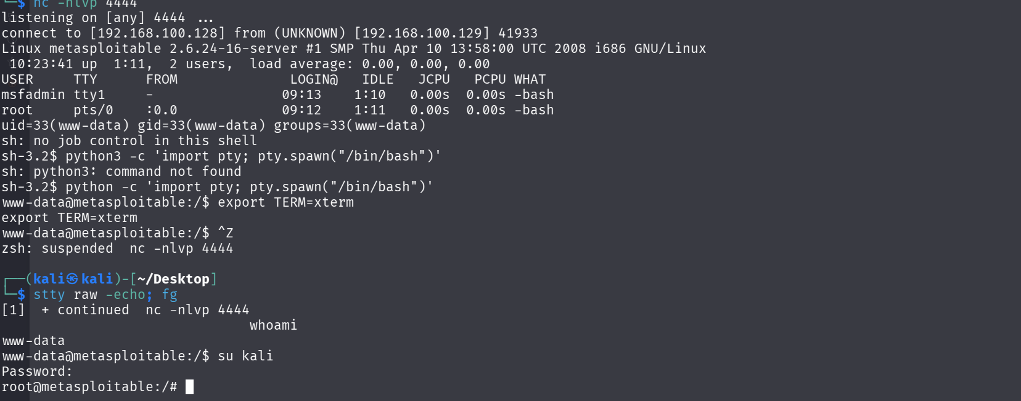

- Testing for SQL Injection on DVWA
We are trying to bypass a login page by using SQL injection. We will first test if the websites database is vulnerable to SQL injection or not. We will do it by using the manual SQL injection command ‘ OR ‘1’ = 1.
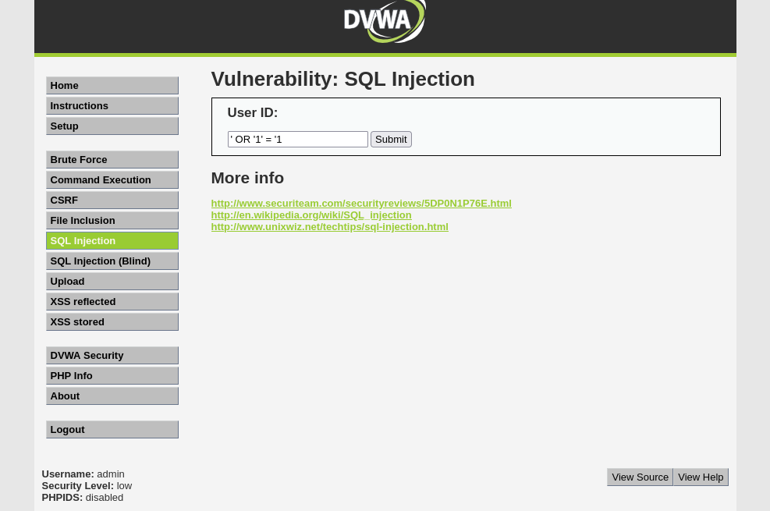
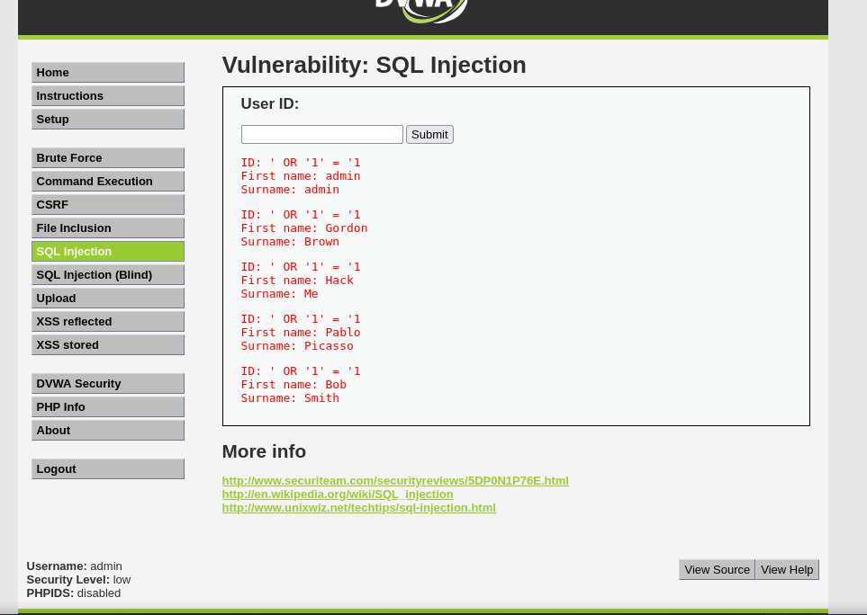
By the above response we are able to confirm that this websites database is vulnerable to SQL injection. The response basically dumped list of all usernames and last names. To Proceed Further we will use SQLmap an automated tool to perform SQL injection.

- Using SQLmap on DVWA website.
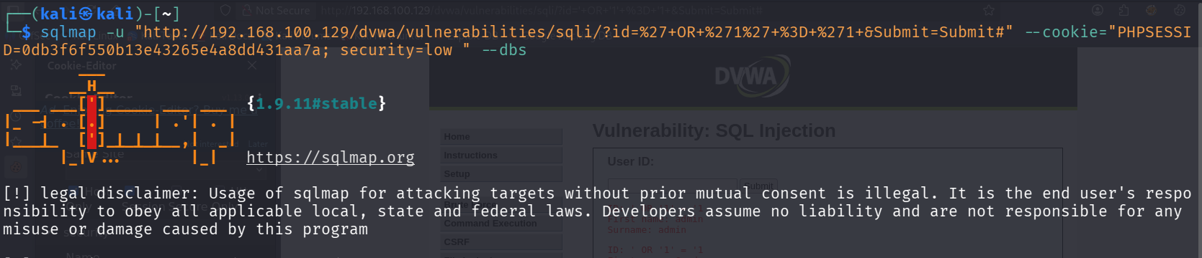
Now by the above screenshot we can see that we use -u flag to enter website address after first manual test case. We also use --cookie header to enter cookies of the website i.e. PHPSESSID and security.

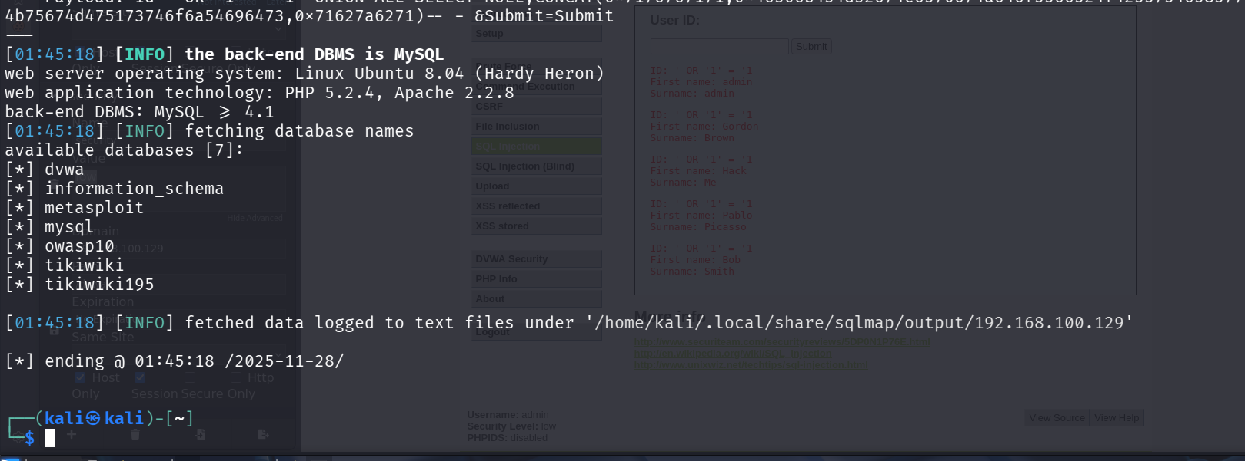
By the above screen shot we can see that we were successfully able to exfiltrate DVWA’s database using SQLmap tool. This demonstration strongly proves the existence of SQL injection vulnerability and how data theft is a possible case by threat attackers.

Vulnerabilities Logs
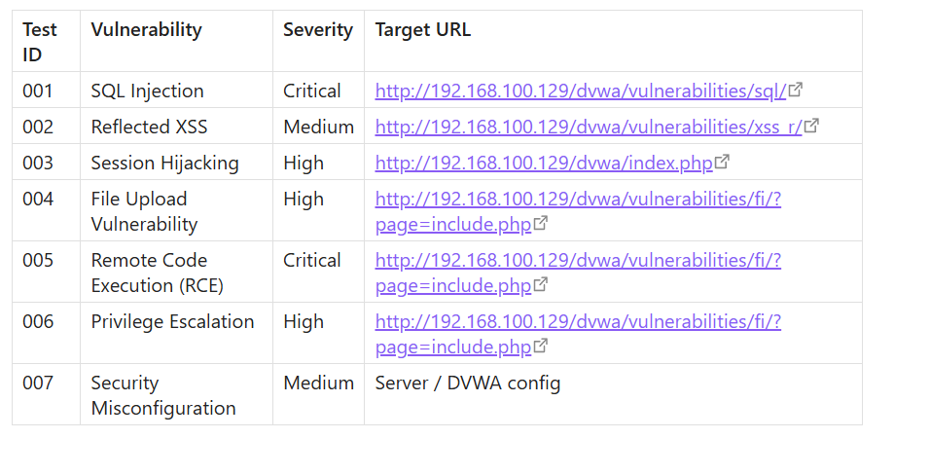

Web Test Summary
The Penetration Testing was done on the website DVWA using manual techniques and automated techniques. Weakness, Vulnerabilities and Misconfigurations were Identified which include critical vulnerabilities like SQL injection, XSS (Cross site scripting), session hijacking, File upload vulnerability,
Remote code execution, Privilege escalation due to Severe server misconfiguration NFS no_root_squash. Findings were demonstrated in the documentation which pose significant risk to confidentiality, integrity and availability requiring immediate remediation.

